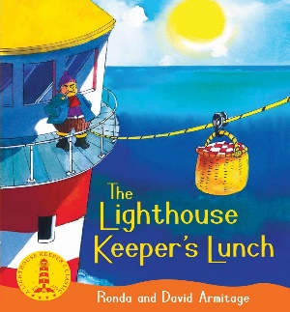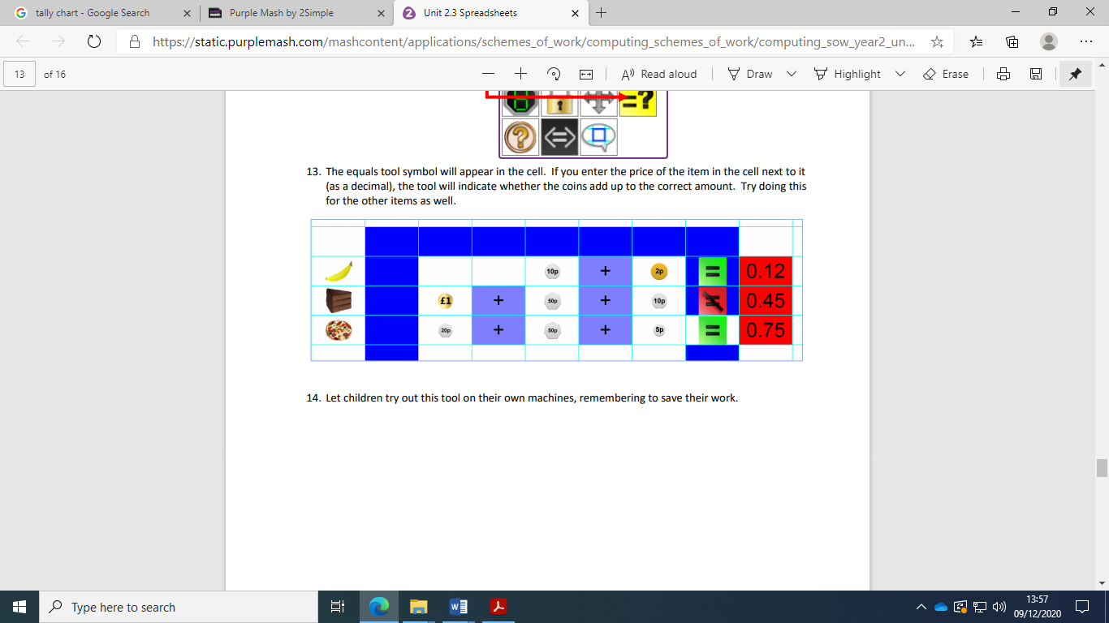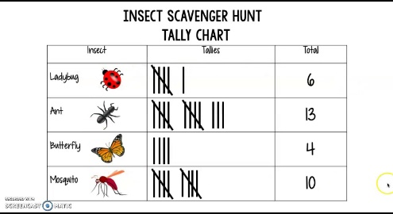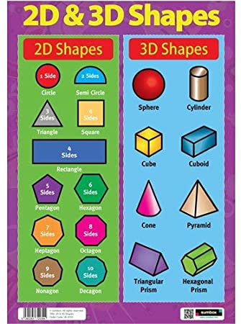

**The Arts**

In Music this half term, our new topic is **‘Travel’.** We will be using a range of instruments as well as our voices to practise performing.

In Art we will be exploring the wheel using paint and collage. In DT we have just finished our Mechanisms unit with wheels and axels in which the children made their own vehicle.

**Humanities**

In History this half term we will be studying **The Plague / Florence Nightingale and The Great Fire of London.**

In Geography we will be looking at Oceans and Continents. We will compare and contrast each of them and their unique features.

**‘Seeking Growth Together’**

Our work this half term will focus on the lead up to Christmas-an important part of the Liturgical Calendar. We will be looking at prayer in the life of Jesus, moving on to the Feast of Christ the King and eventually Advent.

We will also be studying a famous Saint- Mary Magdalene.

**Home Learning Platforms**

We will be using **Microsoft Teams** to upload homework assignments for you to complete.

Homework assignments are set on a Thursday and are expected to be uploaded onto Teams by the following Thursday.

You should also be accessing **Spelling Shed and Purple Mash** as much as you can at home. These are all excellent platforms to assist your child’s learning. If you can’t get onto teams please let your child’s teacher know as soon as possible.

**ICT**

We will this term be looking at spreadsheets and making rows and columns add up to make a total.

**PE**

In **PE**, we will be delving into the past to discover some old fashioned playground games.

We will be developing our PE skills by working on the fundamental movement skills in game scenarios.

**Science**

Our topic this half term will be looking at **‘Growing Up’.**

This topic will allow us to compare and contrast the differences between babies, children, and adults.

We will learn about what babies need when they are born and how they eventually grow into adults.

**Maths**

This half term we will be looking at Multiplication, geometry and statistics. For multiplication we will be investigating groupings, sharing and then word problems. Statistics we will be making tally charts and pictograms. With the information gathered we will then interpret them to see our findings. In shape we will be looking at new language such as vertices and symmetry. We will also be using the iPads to draw shapes and write down the properties of each one.

**English**

This half term we will be looking at the book by Ronda and David Armitage – The Lighthouse Keepers Lunch. Looking at vocabulary, instructions and letters. Postcards will be made from the point of view of Lighthouse keeper as he gets very cross! For SPaG we will be looking at suffixes and contractions – in order to improve writing.