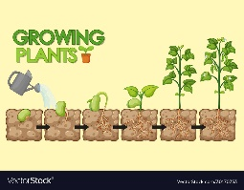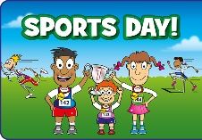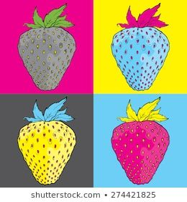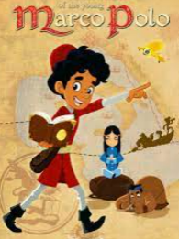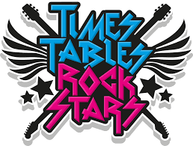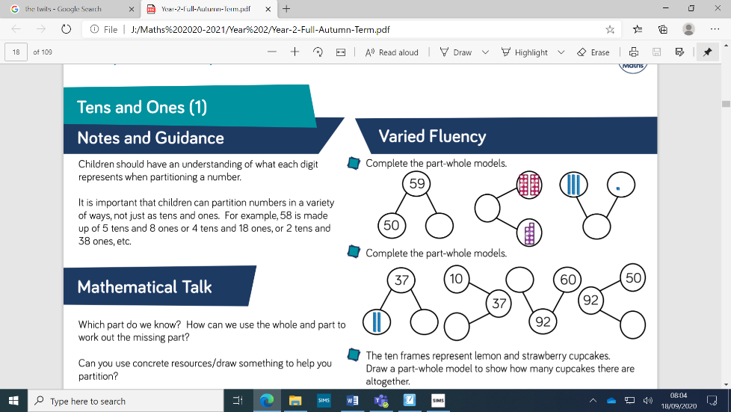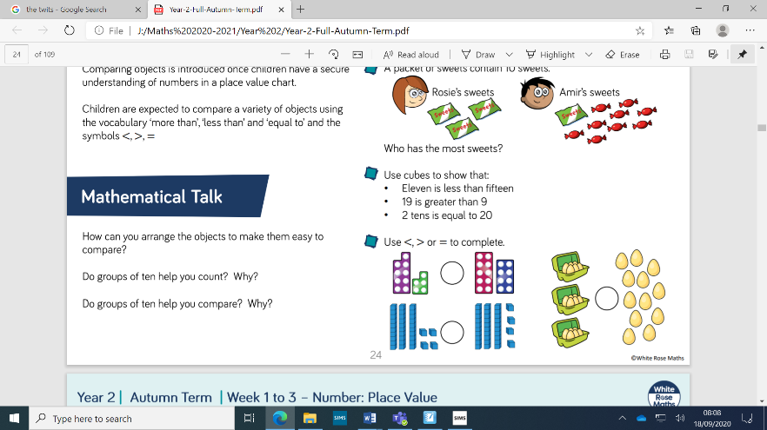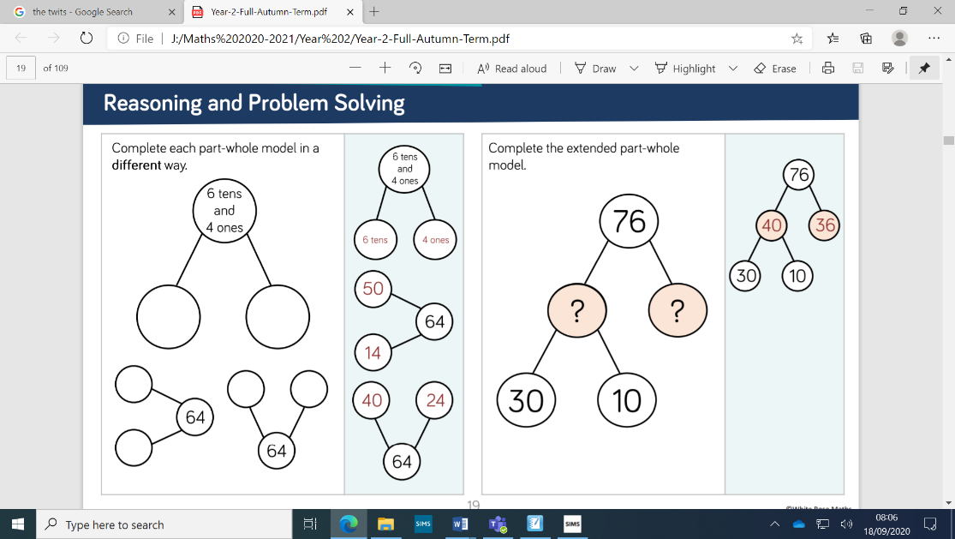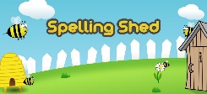

**‘Seeking Growth Together’**

We will be looking at scriptural images this term, talking about our wonders, thoughts and feelings. We will delve into the Jewish religion and compare the similarities and differences from our own faith. The children will be finding out what is in their Community and how we can improve things it in and how we can make my class a safe and fair place. Friendships, what does that mean and how can we reconcile our differences if we do fall out.

**Humanities**

We will be continuing our learning on Continents and Oceans this term, looking deeper into what makes each of the continents unique.

We will also continue with our 3 topics: Florence Nightingale, Great Fire of London and the Plague, in our History lessons. We will be learning new vocabulary such as ‘influential’ and apply this learning to each of our topics.

**The Arts**

This half term the children will be looking at different types of Art and Artists. This includes monoprinting using carbon copy paper to draw fruit and Andy Warhol pictures too.

**ICT**

We will be again looking at Purplemash and ways of searching on the internet. The children will be finding out how you can search and effectively and then making a leaflet about it. The children will also be looking at keeping safe

online too.

**PE**

This half term we have been focusing on athletics in preparation for our KS1 Sports Day. Once complete, we will return to team games, incorporating attacking and defending skills into a game scenario.

**Science**

This term the children will look in depth at Plants and how they grow. They will investigate topics such as growing plants from bulbs and from seeds, learning the sequence of germination, and comparing and contrasting the requirements of germinating seeds with those of mature plants to maintain healthy growth.

The children will have many

opportunities to ask

questions, experiment and

record their findings.

**Home Learning Platforms**

We will be using Microsoft Teams for our homework. Don’t forget to upload once completed. Spelling shed is our spelling online programme and TTRockstars is our Times table game which the children love to play.

**Maths**

We will be following the White Rose scheme of work this term, investigating deeper into weight and volume measurement.   
The children in Year 2 will be working hard to solve a range of different word problems and apply the knowledge they have learned in each area to these questions.   
We will also continue to work on arithmetic every week to build fluency in this area.

**English**

For English will be looking at Poetry. The children will be reading a range of poems including, the seefood diet, Seagulls and the Dentist and the Crocodile. They will be making their own poems based on these in both books and typed up on the computer.

We will also look at 3

famous people –

Leonardo Da Vinci,

Marco Polo and Queen

Elizabeth II. We will be

Investigating where they

lived and what they did to be famous.