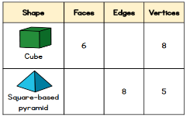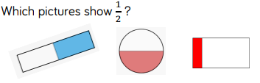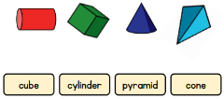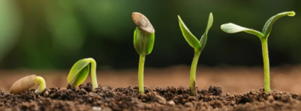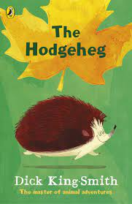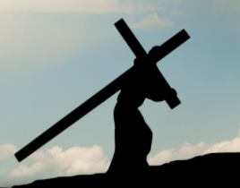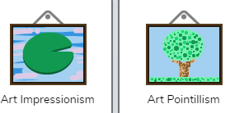 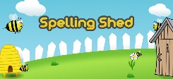

**Maths**

We follow the White Rose scheme of work and in this half term we will be looking at shapes and fractions. The children will be finding out an amount, colouring parts of shapes, looking at a range of items and working out ½ and ¼.

**Science**

In Science, we will be covering the topic ‘The Apprentice Gardener’. Children should already be aware that plants need water and sunlight; this module revisits and extends that understanding from Y1. They are also introduced to growing plants from bulbs and from seeds, learning the sequence of germination, and comparing and contrasting the requirements of germinating seeds with those of mature plants to maintain healthy

growth.

**‘Seeking Growth Together’**

For RE the children will be looking at Moses in the Old Testament, Luke in the New Testament. The children will also be looking at the key events and characters in Palm Sunday, Last Supper, Good Friday

and Easter Sunday.

**Humanities**

Oceans and continents this half term. Labelling where the continents are in the world as well as naming the oceans. 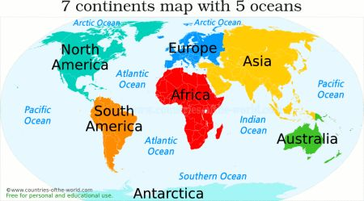

**The Arts**

In DT we will be preparing fruit and vegetables and will make a kebab. In Art we are looking at animals and will be designing and making animal masks. In music our focus song is Zootime which is Reggae song. Over the next few weeks we will learn

the song and

listen to and

appraise other

Reggae music.

**ICT**

We will be looking at Purplemash and Creating pictures, through different mediums

**PE**

Our PE days are Thursday and Friday. Please make sure the children have their PE kit on both days . Playground games – hopping,

skipping, ball

control,

catching etc!!!

**Home Learning Platforms**

A big focus this half term on

SPELLING!! We will be having

competitions for our spelling and having plenty of fun along the way! There will also be a big push on Times tables – please make sure they are chanting them out loud as well as playing TTRockstars.

**English**

We will be in our groups for Read Write Inc. This a tailored programme which zones in on exactly what the children know and what they need to move onto in terms of reading and fluency. Please read with your child as often as you can making sure they have some pace and understanding. Its always great for the adult to read their child’s reading book too – the children love this and it is very beneficial. Those children who have completed the ‘Read, Write, Inc’ programme will be reading ‘The Hodgeheg’ by Dick King Smith. If you get the opportunity at home,

see if you can read any other

books by Dick King Smith.